A look at biotech's year of the megaround
Kyle LaHucik
Senior Reporter
2024 was the year of the private megaround.

Nine-figure financings dominated biotech’s venture funding landscape, with 96 such rounds tallied by Endpoints News. The bevy of megarounds drowned out smaller investments and perhaps diverted some capital away from earlier-stage, nascent ideas that in the heydays of 2020 and 2021 would’ve gotten more attention from investors.
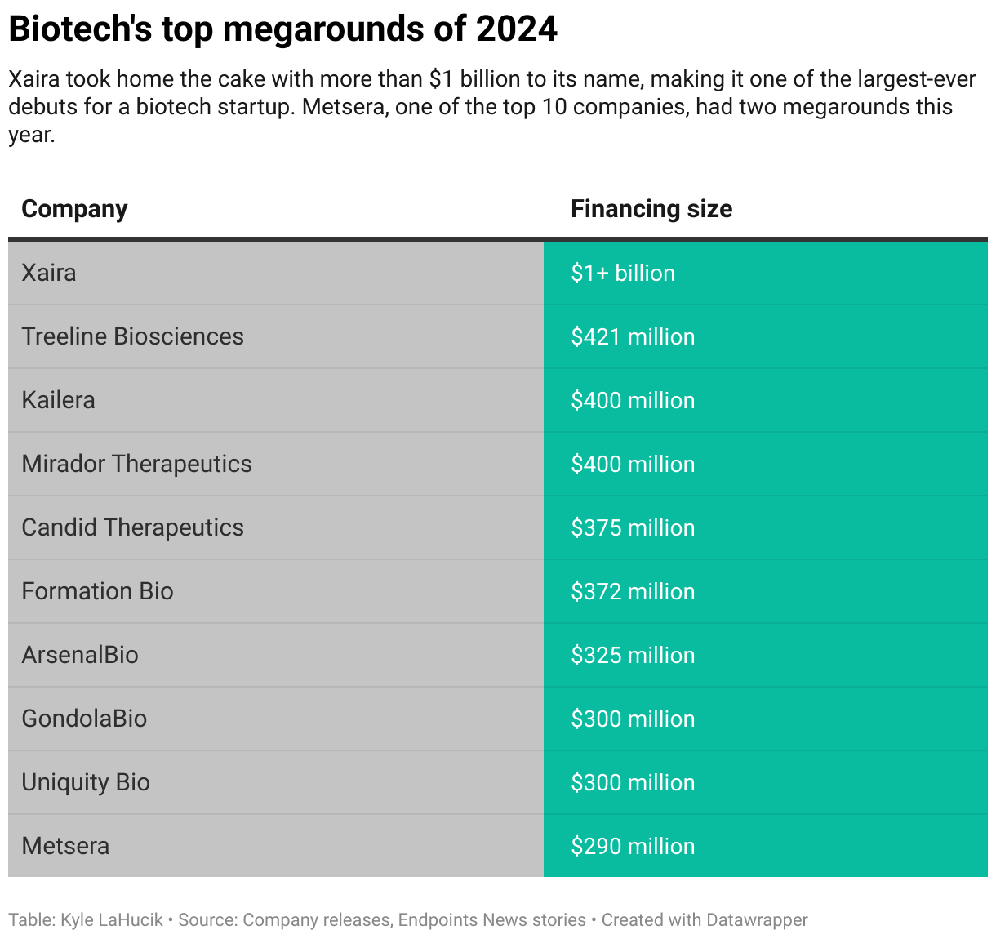
“Everything takes more money to do. That’s a part of it,” said Srinivas Akkaraju, founder of Samsara BioCapital, which invested in multiple megarounds in 2024, including Ottimo Pharma’s $140 million Series A on Dec. 19.

The breakneck pace of megarounds beat the prior two years and comes close to the tally of 106 recorded by Silicon Valley Bank in 2021. It also shows investors are concentrating their bets on proven management teams and drug candidates that are already being tested in humans. (That said, preclinical companies still attracted nearly one-third of the splashy financings).

Jonathan Norris, a managing director in the healthcare banking division of HSBC, told Endpoints he counted 106 megarounds in 2024. In an email, he highlighted that the median post-money valuation has significantly increased for crossover deals. In 2021, the median was $280 million. In 2024, it was $370 million.

With IPOs still largely out of the question, startups need more fuel to last through the so-called winter on the public markets.

“If we give a little bit more, what is the impact on your budget and runway? Can we, for example, tranche it in a way that is still acceptable from a risk perspective, but it doesn’t necessarily require a public market to get to that key value inflection point?” asked Wouter Joustra, general partner at Forbion.

The Dutch biotech investor took part in 10 megarounds in 2024, and the firm leads about 90% of the deals in which it’s involved, Joustra said.
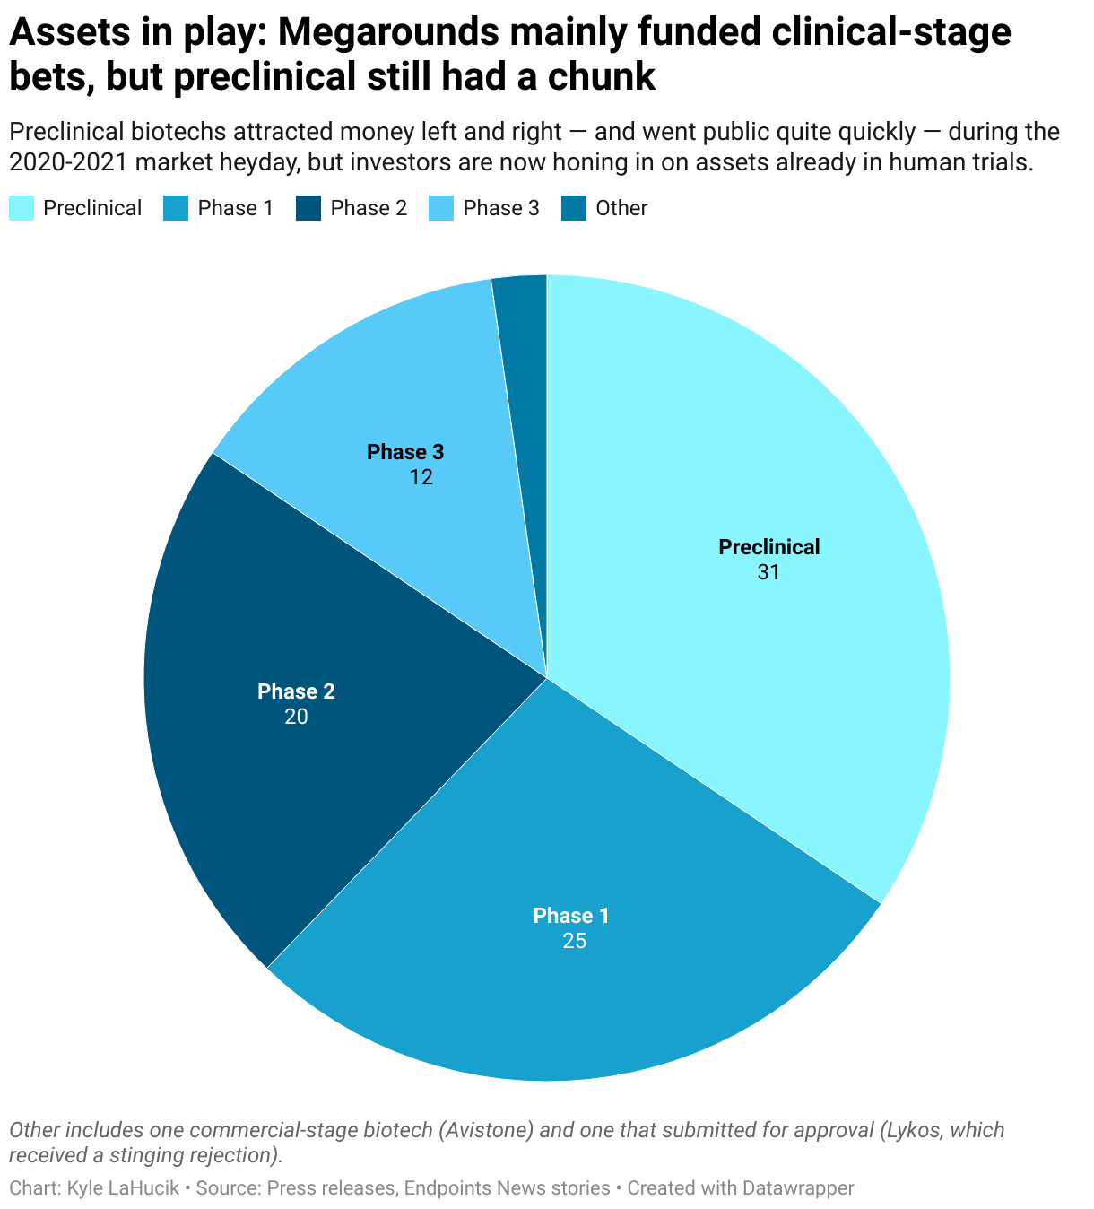
The large financings can also attract better management teams and higher-quality employees down the line, according to both Joustra and Akkaraju.

“Some C-suite members that otherwise would have been in a public company are now more comfortable to go to a private company with a megaround, because they see that refinancing risk is significantly lower than it might have been otherwise,” Joustra said.

Investors are also injecting more capital so that startups have fewer fundraising headaches — and distractions to clinical development — in the years to come.

“In many cases, what I find is, management teams will actually raise the money that they know they need, but they would prefer to have 10% to 20% more,” Akkaraju said. That’s “either for cushion, or the classic is, ‘We’re generating this data, but we didn’t put into the budget all the extra shit we got to do that if the data is positive, we can start the next trial immediately or very quickly instead of a one-year gap.’”
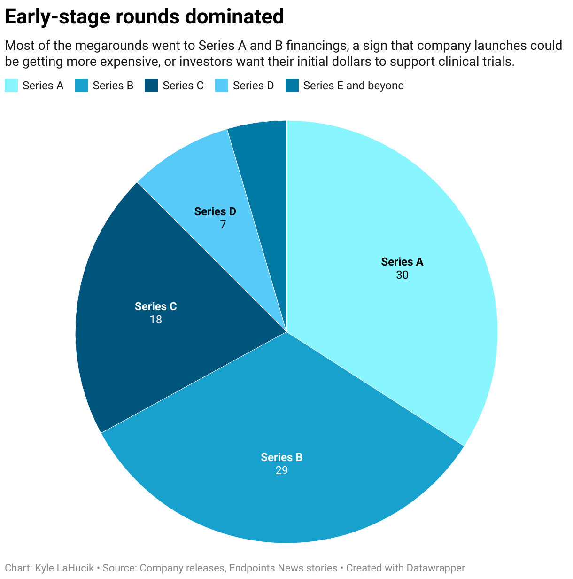
It’s too early to tell what kind of impact, if any, President-elect Donald Trump’s various healthcare appointees could have on the industry. It might lead investors to further concentrate their bets, according to Akkaraju, and that means megarounds could remain popular.

“Whereas we were going into … a nice, slow ramp-up to a better and more and more constructive mentality about investing into companies, I think we’ve taken at least a half-step back, if not a full step back,” Akkaraju said. “We’ll see how things hopefully stabilize over the course of the first couple of quarters next year.”

A look into the numbers
Ninety-six is a decent sample size, so we took a look at the profiles of the companies that recorded megarounds. Most were US-based, with about a dozen in Europe and two in China. (There is a chance we missed some megarounds. Not all are disclosed on time, and there could have been language barriers.)

Of the 94 companies, 14 have a female CEO. Five companies appeared to have no CEO. Only two have already been acquired or merged. In April, Genmab scooped up ADC maker ProfoundBio, and in December, Nvelop merged with Chroma less than a year after coming out of stealth. Three went public: Alumis, BioAge and Zenas.

About one-third (33 companies) are fully, or have a foot, in oncology. Only three companies are known to be working in obesity. With so much investor and large pharma interest in obesity drugs, one would think that stat would be higher.
Major Biotech Company Financings
$1 Billion+
- Xaira
  - Amount: $1+ billion
  - Focus: Undisclosed
  - Round: Series A
$300-500 Million
- Treeline Biosciences
  - Amount: $421 million
  - Focus: Oncology
  - Round: Series A
- Hercules CM NewCo / Kailera
  - Amount: $400 million
  - Focus: Obesity
  - Round: Undisclosed
- Mirador Therapeutics
  - Amount: $400 million
  - Focus: Immunology
  - Round: Series A
- Candid Therapeutics
  - Amount: $375 million
  - Focus: Autoimmune
  - Round: Undisclosed
- Formation Bio
  - Amount: $372 million
  - Focus: I&I, others
  - Round: Series D
- ArsenalBio
  - Amount: $325 million
  - Focus: Oncology
  - Round: Series C
- GondolaBio
  - Amount: $300 million
  - Focus: Rare diseases
  - Round: Tranched financing
- Uniquity Bio
  - Amount: $300 million
  - Focus: I&I and respiratory
  - Round: Series A
$200-299 Million
- Metsera
  - Amount: $290 million
  - Focus: Obesity
  - Round: Series A
- Cardurion
  - Amount: $260 million
  - Focus: Cardiovascular
  - Round: Series B
- Alumis
  - Amount: $259 million
  - Focus: Autoimmune
  - Round: Series C
- Seaport Therapeutics
  - Amount: $225 million
  - Focus: Neuroscience
  - Round: Series B
- AltruBio
  - Amount: $225 million
  - Focus: Autoimmune
  - Round: Series B
- Metsera
  - Amount: $215 million
  - Focus: Obesity
  - Round: Series B
- ITM
  - Amount: $204 million
  - Focus: Oncology
  - Round: Equity investment
- BridgeBio Oncology Therapeutics
  - Amount: $200 million
  - Focus: Oncology
  - Round: Series B, spinoff
- Zenas Biopharma
  - Amount: $200 million
  - Focus: Autoimmune
  - Round: Series C
$150-199 Million
- eGenesis
  - Amount: $191 million
  - Focus: Organ transplant
  - Round: Series D
- Marea Therapeutics
  - Amount: $190 million
  - Focus: Cardiometabolic
  - Round: Series A + B
- Bluejay Therapeutics
  - Amount: $182 million
  - Focus: Hepatitis
  - Round: Series C
- Sionna Therapeutics
  - Amount: $182 million
  - Focus: Cystic fibrosis
  - Round: Series C
- Alentis Therapeutics
  - Amount: $181.4 million
  - Focus: Oncology, fibrosis
  - Round: Series D
- Alpha-9 Oncology
  - Amount: $175 million
  - Focus: Oncology
  - Round: Series C
- Aktis Oncology
  - Amount: $175 million
  - Focus: Oncology
  - Round: Series B
- Capstan Therapeutics
  - Amount: $175 million
  - Focus: Autoimmune, oncology, fibrosis, blood
  - Round: Series B
- Beacon Therapeutics
  - Amount: $170 million
  - Focus: Ophthalmology
  - Round: Series B
- BioAge Labs
  - Amount: $170 million
  - Focus: Obesity, metabolic diseases
  - Round: Series D
- Third Arc Bio
  - Amount: $165 million
  - Focus: Oncology and I&I
  - Round: Series A
- Ji Xing Pharmaceuticals (now CORXEL)
  - Amount: $162 million
  - Focus: Cardiovascular, ophthalmology
  - Round: Series D
- Nuvig Therapeutics
  - Amount: $161 million
  - Focus: Autoimmune
  - Round: Series B
- Obsidian Therapeutics
  - Amount: $160 million
  - Focus: Oncology
  - Round: Series C
- TORL Biotherapeutics
  - Amount: $158 million
  - Focus: Oncology
  - Round: Series B-2
- Engrail Therapeutics
  - Amount: $157 million
  - Focus: Neuroscience
  - Round: Series B
- Avenzo Therapeutics
  - Amount: $150 million
  - Focus: Oncology
  - Round: Series A extension
- Ascendis spinoff Eyconis
  - Amount: $150 million
  - Focus: Ophthalmology
  - Round: Spinoff launch
- Clasp Therapeutics
  - Amount: $150 million
  - Focus: Oncology
  - Round: Seed + Series A
- Scorpion Therapeutics
  - Amount: $150 million
  - Focus: Oncology
  - Round: Series C
- CatalYm
  - Amount: $150 million
  - Focus: Oncology
  - Round: Series D
$100-149 Million
- FogPharma / Parabilis
  - Amount: $145 million
  - Focus: Oncology
  - Round: Series E
- Outpace Bio
  - Amount: $144 million
  - Focus: Oncology
  - Round: Series B
- EvolutionaryScale
  - Amount: $142 million
  - Focus: Undisclosed
  - Round: Seed
- Ottimo Pharma
  - Amount: $140 million
  - Focus: Oncology
  - Round: Series A
- Avistone Biotechnology
  - Amount: $140 million
  - Focus: Oncology
  - Round: Series B
- Tubulis
  - Amount: $138 million
  - Focus: Oncology
  - Round: Series B2
- Adcendo
  - Amount: $135 million
  - Focus: Oncology
  - Round: Series B
- Latigo Biotherapeutics
  - Amount: $135 million
  - Focus: Pain
  - Round: Series A
- City Therapeutics
  - Amount: $135 million
  - Focus: Undisclosed
  - Round: Series A
- Endeavor BioMedicines
  - Amount: $132 million
  - Focus: Fibrosis, oncology
  - Round: Series C
- Alterome
  - Amount: $132 million
  - Focus: Oncology
  - Round: Series B
- Enveda
  - Amount: $130 million
  - Focus: I&I, oncology, neuro, others
  - Round: Series C
- Diagonal Therapeutics
  - Amount: $128 million
  - Focus: Rare diseases, cardio
  - Round: Seed + Series A
- Halda Therapeutics
  - Amount: $126 million
  - Focus: Oncology
  - Round: Series B extension
- Santa Ana Bio
  - Amount: $125 million
  - Focus: I&I
  - Round: Series B
- NGM Bio
  - Amount: $122 million
  - Focus: Rare disease
  - Round: Series A
- Angitia Biopharmaceuticals
  - Amount: $120 million
  - Focus: Musculoskeletal diseases
  - Round: Series C
- Neurona Therapeutics
  - Amount: $120 million
  - Focus: Neurological disorders
  - Round: Series C
- Terray Therapeutics
  - Amount: $120 million
  - Focus: Immunology
  - Round: Series B
- IDRx
  - Amount: $120 million
  - Focus: Oncology
  - Round: Series B
- Superluminal
  - Amount: $120 million
  - Focus: Undisclosed
  - Round: Series A
- Pheon Therapeutics
  - Amount: $120 million
  - Focus: Oncology
  - Round: Series B
- Rakuten Medical
  - Amount: $119 million
  - Focus: Oncology
  - Round: Series E
- Maze Therapeutics
  - Amount: $115 million
  - Focus: Kidney disease, cardiometabolic
  - Round: Series D
- Axonis Therapeutics
  - Amount: $115 million
  - Focus: Neuro, pain
  - Round: Series A
- Evommune
  - Amount: $115 million
  - Focus: I&I
  - Round: Series C
- Triveni Bio
  - Amount: $115 million
  - Focus: I&I
  - Round: Series B
- Myricx Bio
  - Amount: $114 million
  - Focus: Oncology
  - Round: Series A
- AvenCell
  - Amount: $112 million
  - Focus: Oncology
  - Round: Series B
- Elektrofi
  - Amount: $112 million
  - Focus: Multiple
  - Round: Series C
- ProfoundBio
  - Amount: $112 million
  - Focus: Oncology
  - Round: Series B
- Lycia Therapeutics
  - Amount: $106.6 million
  - Focus: Autoimmune and inflammatory diseases
  - Round: Series C
- COUR Pharmaceuticals
  - Amount: $105 million
  - Focus: Autoimmune
  - Round: Series A
- Pathalys
  - Amount: $105 million
  - Focus: Kidney disease
  - Round: Series B
- Purespring Therapeutics
  - Amount: $105 million
  - Focus: Kidney disease, IgAN
  - Round: Series B
- Attovia Therapeutics
  - Amount: $105 million
  - Focus: Inflammation and immunology
  - Round: Series B
- Reunion Neuroscience
  - Amount: $103 million
  - Focus: Psychedelics, neuroscience
  - Round: Series A
- Synnovation Therapeutics
  - Amount: $102 million
  - Focus: Oncology, inflammation, rare disease
  - Round: Series A
- Trace Neuroscience
  - Amount: $101 million
  - Focus: ALS, neurodegenerative
  - Round: Series A
- NILO Therapeutics
  - Amount: $101 million
  - Focus: Autoimmune
  - Round: Series A
- Lykos Therapeutics
  - Amount: $100 million
  - Focus: PTSD
  - Round: Series A
- OnCusp Therapeutics
  - Amount: $100 million
  - Focus: Oncology
  - Round: Series A
- Alys Pharmaceuticals
  - Amount: $100 million
  - Focus: Dermatology
  - Round: Series A
- BlossomHill Therapeutics
  - Amount: $100 million
  - Focus: Oncology, autoimmune
  - Round: Series B
- Seaport Therapeutics
  - Amount: $100 million
  - Focus: Neuropsychiatric
  - Round: Series A
- Nvelop Therapeutics
  - Amount: $100 million
  - Focus: Undisclosed
  - Round: Seed
- Enlaza Therapeutics
  - Amount: $100 million
  - Focus: Oncology
  - Round: Series A
- Amber Therapeutics
  - Amount: $100 million
  - Focus: Women's health
  - Round: Series A
- Alzheon
  - Amount: $100 million
  - Focus: Alzheimer's
  - Round: Series E
- Asceneuron
  - Amount: $100 million
  - Focus: Alzheimer's
  - Round: Series C
- Autobahn Therapeutics
  - Amount: $100 million
  - Focus: CNS
  - Round: Series C
- Navigator Medicines
  - Amount: $100 million
  - Focus: Autoimmune
  - Round: Series A
- F2G
  - Amount: $100 million
  - Focus: Fungal infections
  - Round: Series H
- Vicebio
  - Amount: $100 million
  - Focus: RSV, respiratory diseases
  - Round: Series B
- Judo Bio
  - Amount: $100 million
  - Focus: Kidney diseases
  - Round: Seed and Series A
- SiteOne Therapeutics
  - Amount: $100 million
  - Focus: Pain
  - Round: Series C
- Syncromune
  - Amount: $100 million
  - Focus: Oncology
  - Round: Series A

